Breaking the Silence – Survey Insights

Introduction
As part of the project “Breaking the Silence: Addressing Mental Health in Pakistan’s Vulnerable Children”, a feedback survey was conducted after interactive sessions. The survey aimed to capture children’s thoughts, moods, emotional states, available support systems, and the impact of the session itself.
Using Python (Pandas, Matplotlib, Seaborn), the responses were analyzed and visualized to highlight key findings. This report documents the results and provides insight into the children’s mental and emotional well-being.

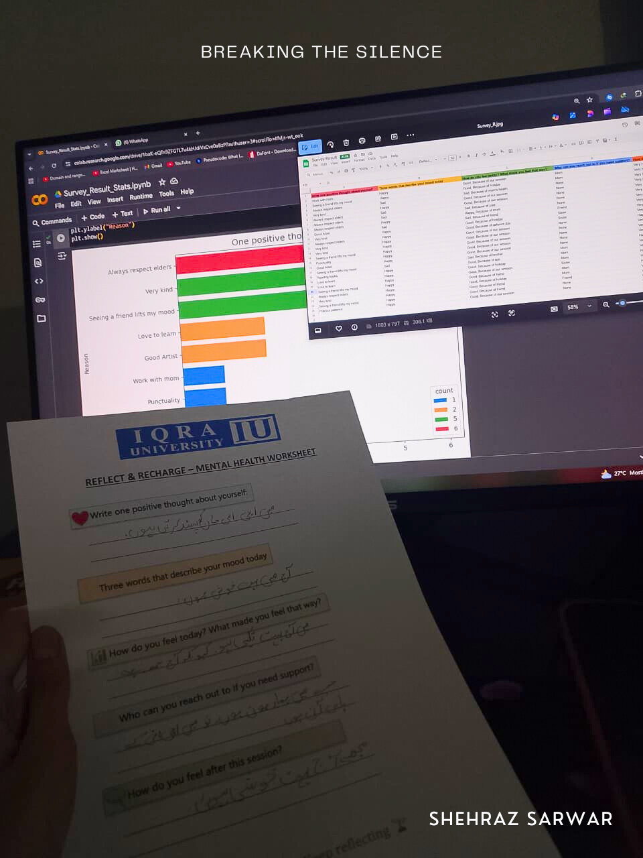

Report prepared and analyzed by Shehraz Sarwar

Survey Insights

1. Positive Thoughts About Themselves (Horizontal Bar Chart)
- Children most often described themselves with traits like “Always respect elders” (6 responses), “Seeing a friend lifts my mood” (5), and “Very kind” (5).
- Other self-reflections included Good Artist, Love to learn, Punctuality, and Reading books.
- Insight: The responses reflect a healthy sense of self-awareness and positivity among children, showing they value respect, kindness, and learning.

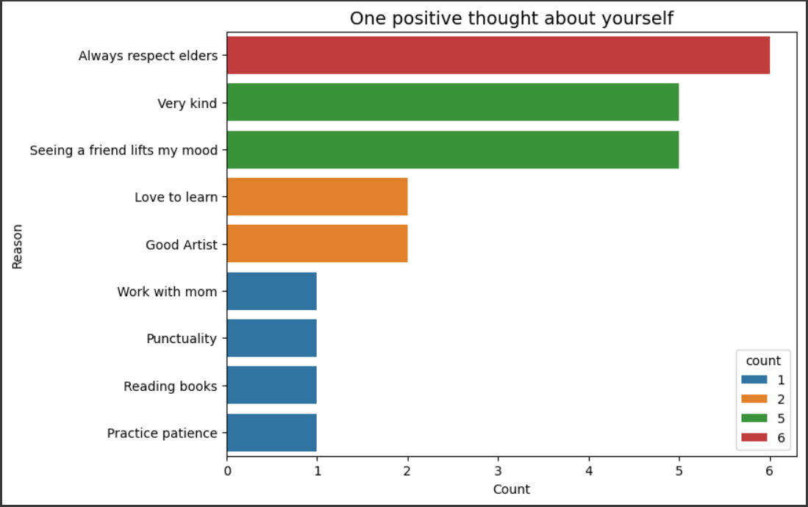

2. Mood Words Today (Vertical Bar Chart)
- Happy was the dominant mood with 19 mentions, compared to Sad (5 mentions).
- Insight: The overwhelming presence of “Happy” indicates that the session environment was uplifting for most participants, though a few children still reflected sadness.

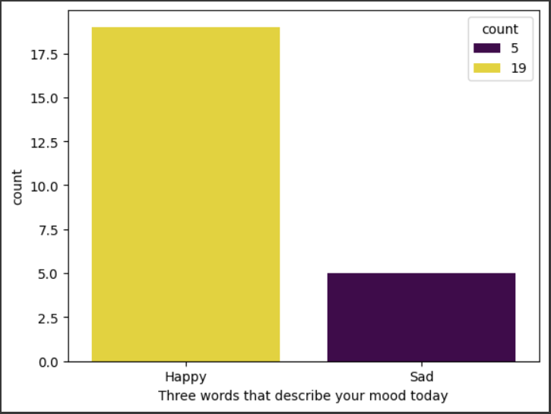

3. Feelings Today & Reasons (Horizontal Bar Chart)
- Good, Because of our session (10) was the most common response, followed by Good, Because of holiday (4) and Good, Because of friend (3).
- A few mentioned sadness due to personal reasons such as mom’s health, past experiences, or friendships.
- Insight: The session itself directly contributed to many children feeling good. However, external stressors like family health issues remain influential in shaping emotions.

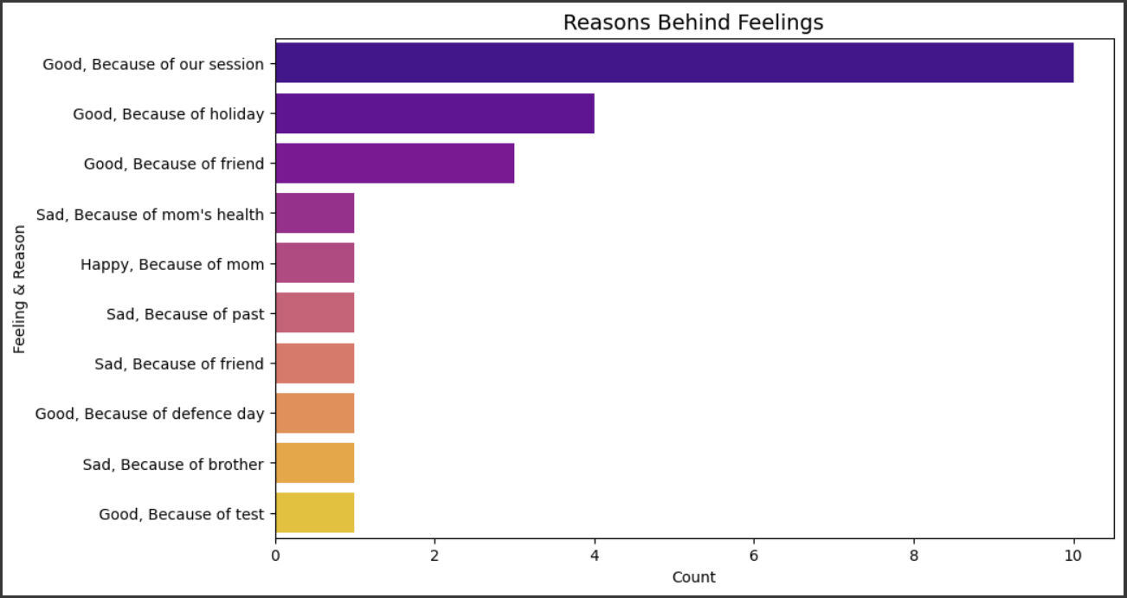

4. Support Systems (Vertical Bar Chart)
- 12 children said “None”, while 7 mentioned Mom, 3 mentioned Sister, and 2 mentioned Friend.
- Insight: Alarmingly, nearly half of the children feel they have no one to turn to for support. This highlights a significant gap in emotional safety nets and underlines the project’s importance in providing such outlets.

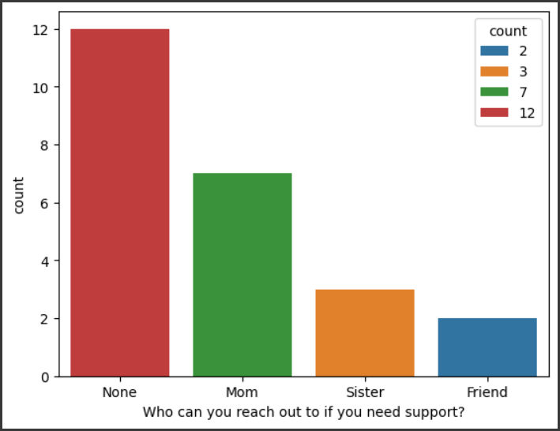

5. Feelings After the Session (Pie Chart with %)
- Very Happy: 19 children (79%)
- Happy: 5 children (21%)
- Insight: Every participant left the session with positive emotions, showing that the activities were impactful in boosting morale and creating a safe, joyful environment.

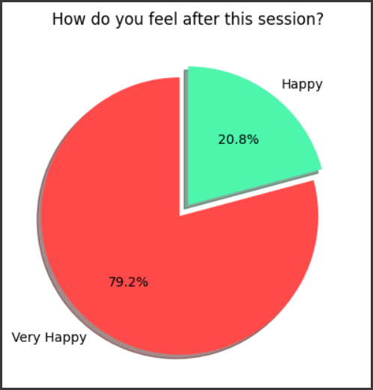

Conclusion
The survey results clearly show the effectiveness of the Breaking the Silence initiative:
- Children are capable of identifying positive traits about themselves.
- Most felt happy and uplifted during and after the session.
- The sessions had a measurable impact in improving mood and emotional well-being.
- However, the lack of strong support systems at home or in their immediate environment is a critical concern that needs to be addressed through continued guidance, safe spaces, and awareness programs.
Overall, this survey reaffirms the project’s mission of reducing stigma, promoting resilience, and fostering open communication on mental health for vulnerable children.

